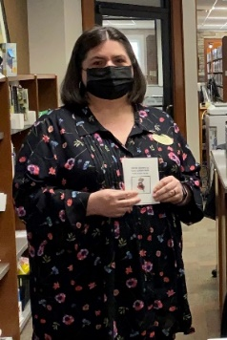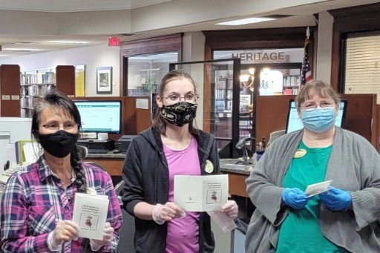
Celebrate Union County Public Library Workers

April 6, 2021 was National Library Workers Day and Friends of Union County Library (FOUCL) recognized the day with a card presentation to Union County Public Library (UCPL) workers. The cards read: “You’ve Shown Us Your Superpower This Past Year. So, We Send You a Super Thank You!”
Public libraries remain one of the best free resources available. EveryLibrary lists these statistics from 2019 (pre pandemic): Almost 100 million more people visit their libraries each year than see a movie at the theater; more than 172 million Americans have library cards (more than half of the American population); librarians answer around 250 million questions from the public each year; millennials use libraries more than any other generation; and Americans check out over 2.1 billion items from their public library every year.
The American Library Association reported in 2020: “The popularity of libraries is surging. The public response to the work of our nation’s libraries is reflected in an increased number of visits.”
According to a 2019 Gallup poll, visiting the library is the “most common cultural activity Americans engage in by far. Despite the proliferation of digital-based activities over the past two decades - including digital books, podcasts, streaming entertainment services, and advanced gaming - libraries have endured as a place Americans visit nearly monthly on average…because they offer services like free Wi-Fi, movie rentals, or activities for children.”
Libraries continue to expand their services but providing books, in many different forms, is still a big part of what they do. Because of contributions from FOUCL, over three dozen new FOUCL-funded books recently became available at UCPL. Just a few of these are listed here. For Juvenile & Young Adults: “Clayton Byrd Goes Underground” by Rita Williams-Garcia, “The Girl Who Drew Butterflies” by Joyce Sidman, and “Keeper of the Lost Cities Series” (Books 1-6) by Shannon Messenger. Fiction for Adults: “The Kitchen House” by Kathleen Grissom and “Caught in Time” by Julie McElwain. Nonfiction for Adults: “Secrets of the Southern Table” by Virginia Willis.
Would you like to contribute toward the purchase of books, library equipment, and program-related expenses at UCPL? Fundraisers like our second May Bakeless Bake Sale raise the money for FOUCL’s financial contributions to our library. Please look for details about this sale in a few weeks and thank you for supporting UCPL and the great people who work there.

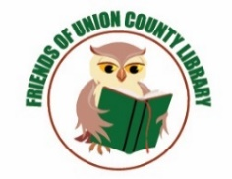
Advocating for Libraries,
Literacy, and Lifelong Learning

